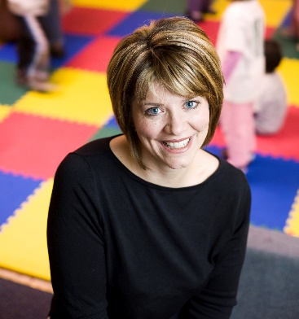

Paula Kluth

Please join CCPS for an evening with

National Inclusive Educator:

**Inclusion:**

**What Every Parent Should Know**

Come and get ideas to help you partner with your child’s teacher. In this presentation, participants will learn about recent research on inclusive classroom, useful supports, and helpful questions to guide your next meeting. Video clips, active learning techniques, and classroom examples will be used to answer questions such as “What is inclusion?”; “How will inclusion benefit my child?”; and “How can I support my child’s inclusive education experience?”

**Monday, March 2, 2020**

**6:30 to 8:00 pm**

**Calvert County Board of Education**

**Multi-Purpose room**

**1305 Dares Beach Road**

**Prince Frederick, MD 20678**

This **FREE** event is open to parents, teachers and community members!

To register: contact Sue Rafalowski at 443-550-8375 or parentconnections@calvertnet.k12.md.us.

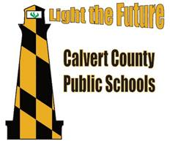

**Special Education Early Childhood**



**Calvert County**

**Partners**

**For**

**Success**